Using the OTS grasshopper model
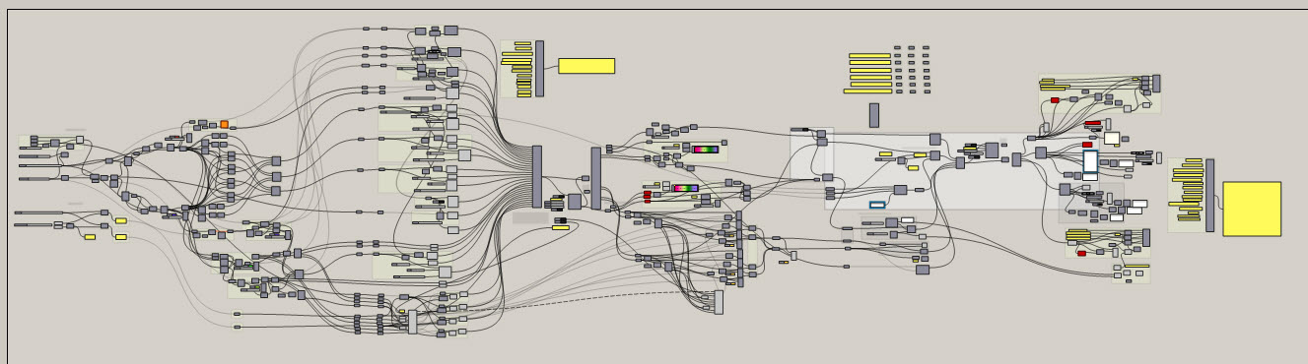
The model has 3 main parts
The initial form and force parameters are developed on the left hand side…
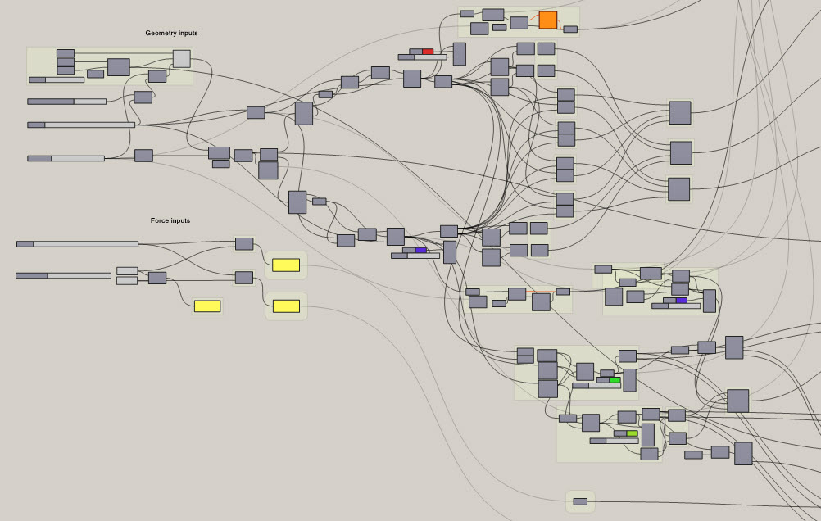
The sliders on the left hand side are used to change the initial state of the model.
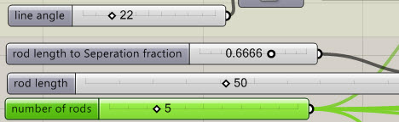
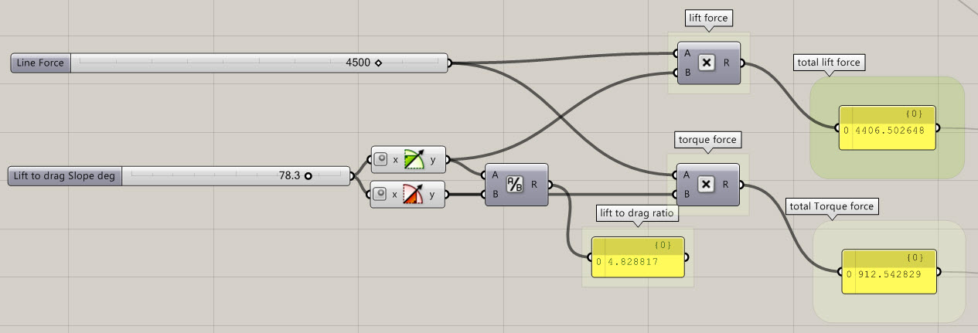

The form and force parameters are sent through a physics simulator (middle section) to find the form under load conditions.
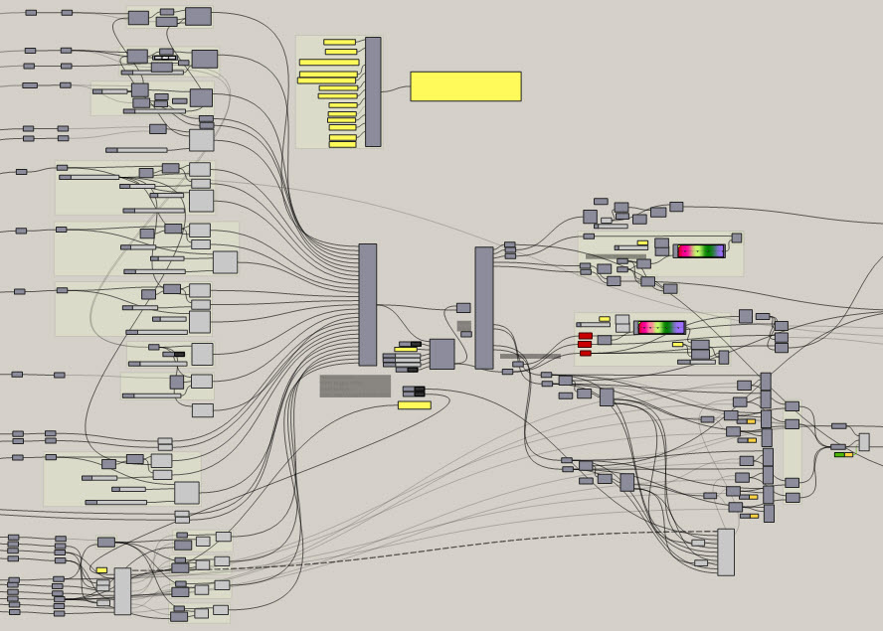
The parts, which define the OTS initial form, are then imported, with matching physical behaviours, or goals, as this kangaroo engine calls them into the kangaroo physics engine … (e.g. goals are …solid part, elastic line, colliding object, end point, anchor, line forces, etc..)
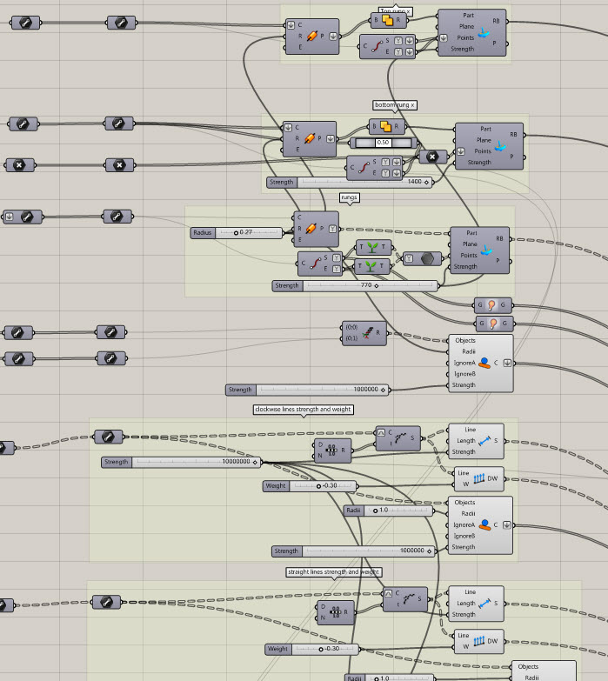
The lower section uses a loop which initially takes line and force data inputs. This data is initially sent to the kangaroo solver. The data processed by the solver is then looped back to be sent into the solver again.
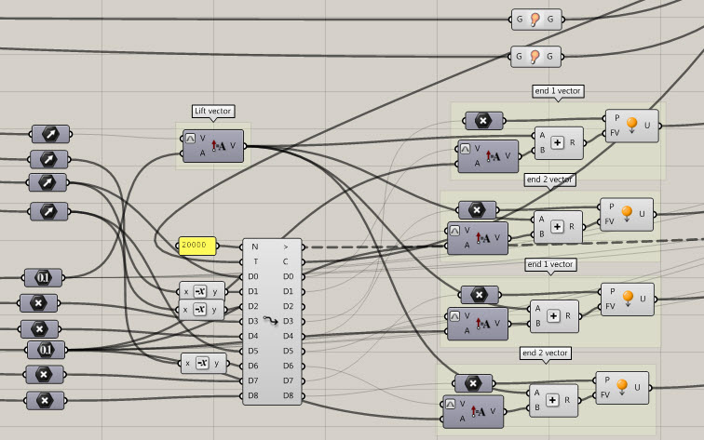
The controls in the centre are used to control the loop function and set the physics solver in motion.
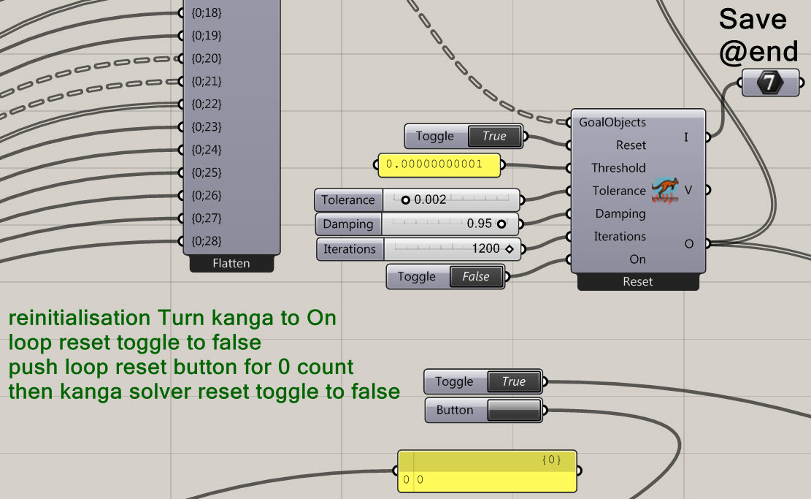
The instructions on the .gh sketch explain the order of how to restart the form finding routine. Hold on though, let’s check we’re ready to start.

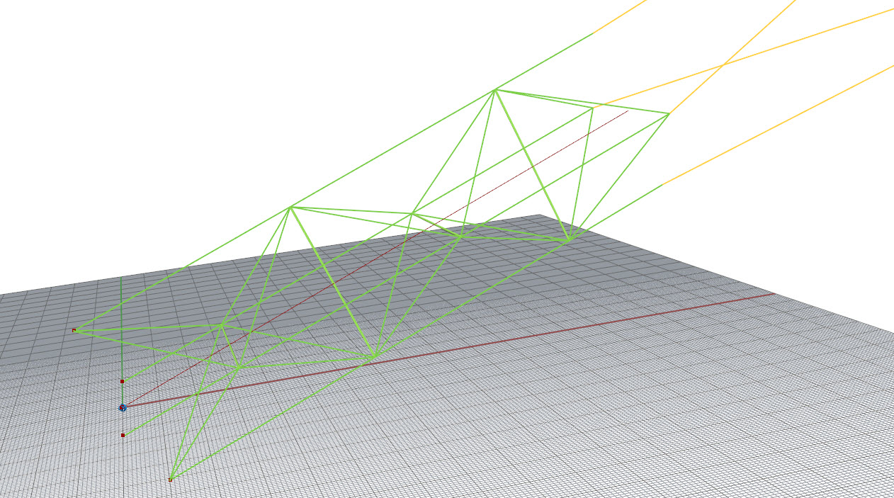
In order to see the model the solver is working on, (like above), make sure that the geometry shading components (seen on the right of the rainbow gradient swatches) have previews on (light grey component) and are not hidden (dark grey component) 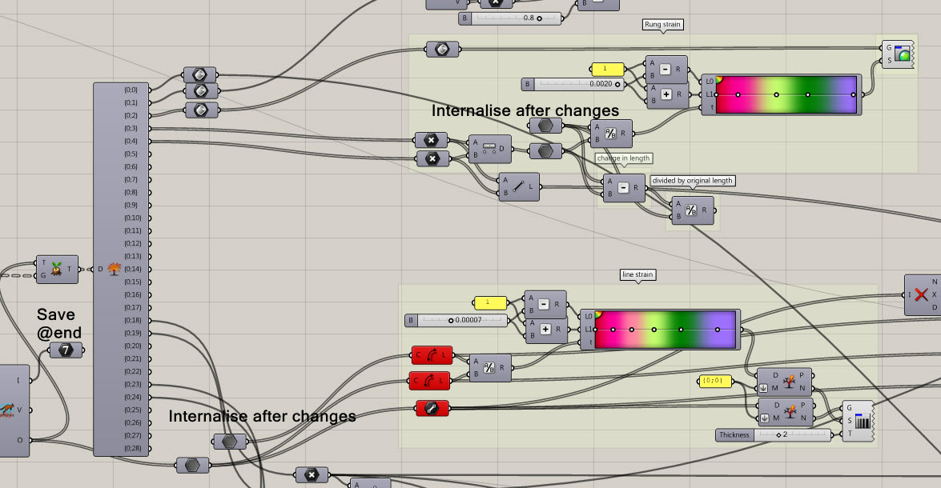
There are three suggested operations. The 2x “Internalise after changes” operations are for strain measurement and visualisation. The instruction is beside two generic data pool components. The lower one has a length input. The upper has nothing. Give the output of the lower data into the upper data component. Right click on the upper data component and click internalise data. This records the initial state before running the physics solver.
The other instruction on the .gh canvas “save @end” is beside an integer component. After the simulation has run, internalise this data to save it (the number of solver iterations) in the component before saving the form finding data.

Initially, before form finding, the right hand side of the canvas, (force analysis) is set as disabled (dark grey and shaded icons with orange data lines) to save processor time.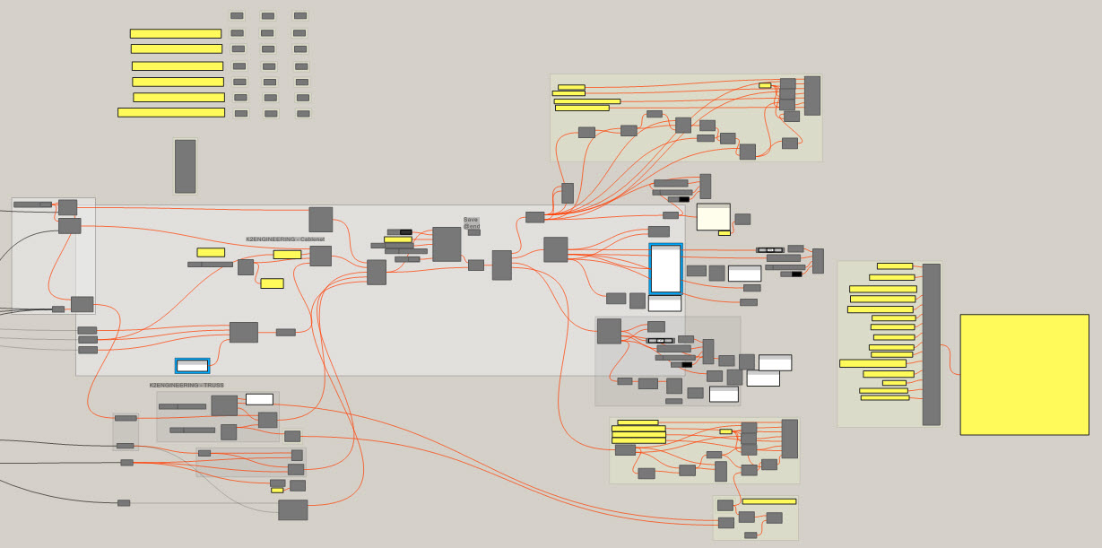
OK now we’re ready to start the form finding. As per the instructions beside the Kangaroo solver
reinitialisation Turn kanga to On
loop reset toggle to false
push loop reset button for 0 count
then kanga solver reset toggle to false
Your model should quickly start to change colour to indicate tensile line strain and rod compression
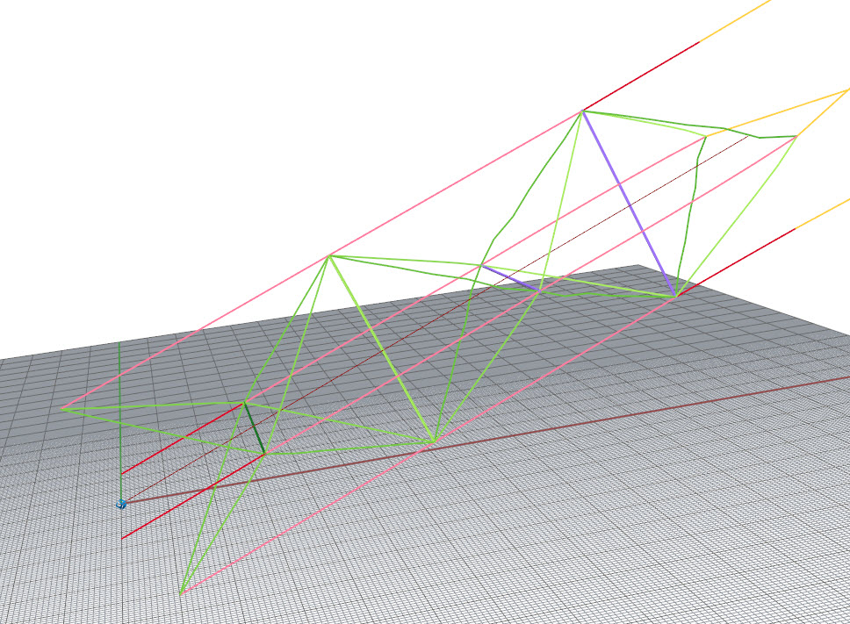
After 30 minutes or so it may look more twisted like…
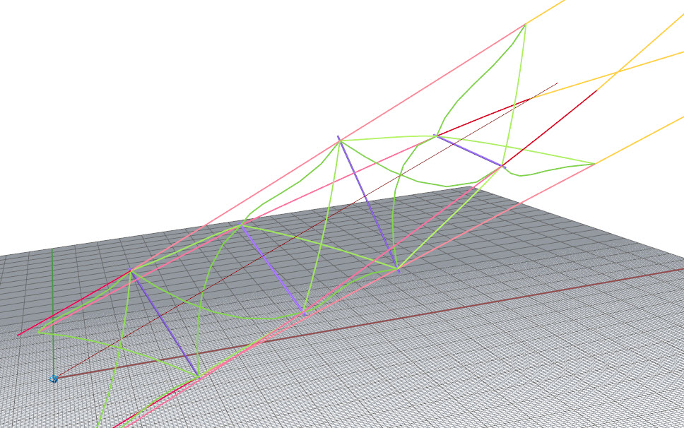
Time now to pause the Kangaroo physics solver by setting the Boolean toggle at the bottom of the solver (on) to false. You can now also stop the loop by setting the next toggle down to true. (annoying opposite logic… true to reset the loop)
Internalise the “save @end “ iterations counter.
Now lets save our some data. Connect the output of the state data to a new set of recording data (copy an old set and rename it ready to overwrite)
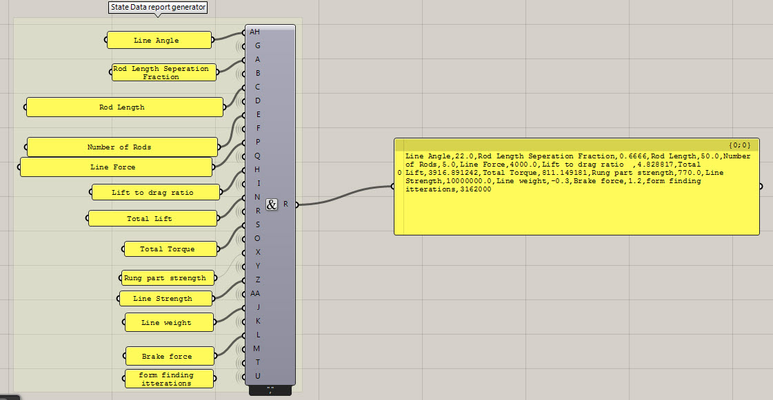
This is the State data. We performed 3162000 iterations (I keep spelling itterations wrong) of form finding. Plug this into the first component in the new set of form data (see below)
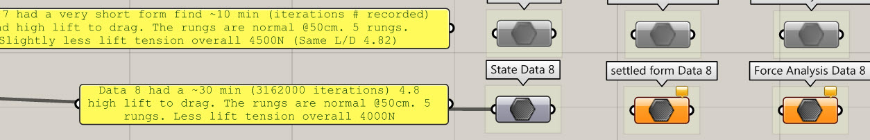
The settled form data is currently disabled. Lets enable the whole right side of the .gh sketch, then save the settled form data. Then right click and internalise the data to save it in this data silo.
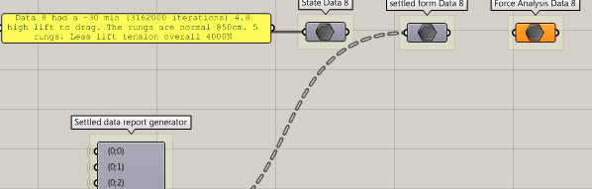
When you selected, right clicked and enabled the right side (force analysis side) of the .gh sketch … the rhino preview screen might have started displaying a whole load of new colours and numbers over your model… this is good. The force analysis is now running.
The force analysis uses the same Kangaroo physics solver to balance the forces within the structure based upon the input forces, anchoring, and properties of the cables and rods. If needed … reset and set the solver running.
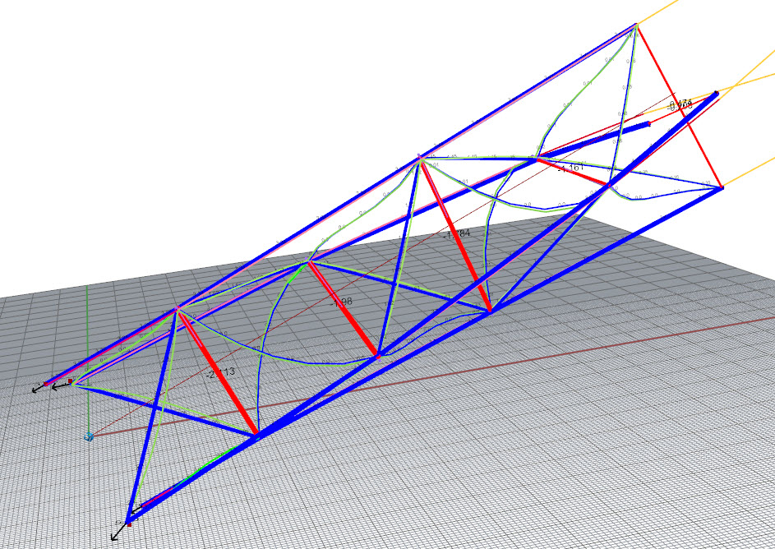
After a few minutes the solver will likely have converged on a balanced solution (where the average movement is within the threshold level)
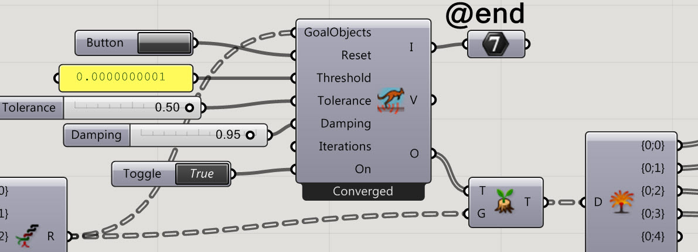
To the right of the solver is the force analysis data. It is collected and ready to record at the very right hand side. (yellow panel component.) Plug this panel into the Force analysis data silo and internalise the data to save it.
With a closer look at the Rhino preview window you can see the forces (kN) on the lines and rods (red is compression blue is tension)
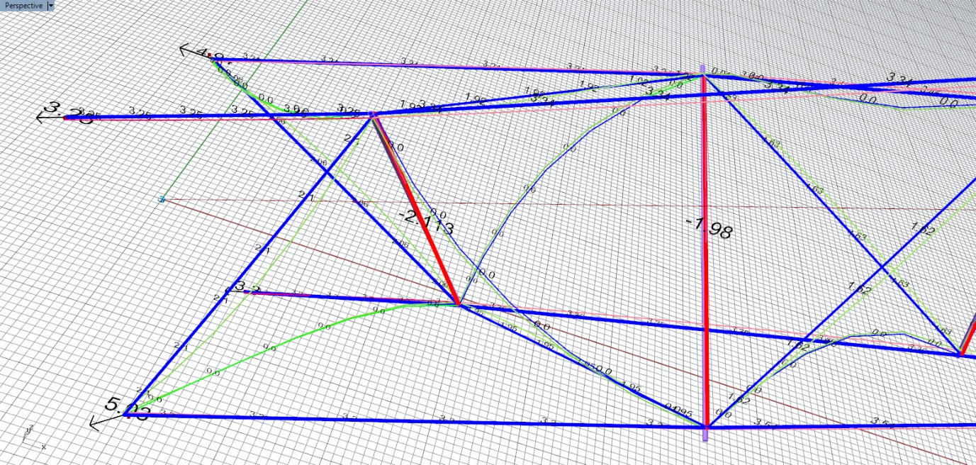
When you’ve had a really good look around. Save a new .gh and you’re ready to start again. Select all of the right hand and disable it. (If you turned off the form finding preview when you were looking around… you’ll need to turn it on again...) Choose some new starting points and run the process again.
Yay

