Kite Turbines and Scaling Airborne Wind Energy Systems using Networks
Authors Roderick Read
Addresses of authors 15a Aiginish, Isle of Lewis, Eilean Siar, Scotland, UK

Author contact email rod.read@windswept-and-interesting.co.uk
Keywords: airborne wind energy, multi-kite, multi-rotor, kite-network, kite-turbine, unconventional power transmission, scalability
- Introduction
The Airborne Wind Energy Systems (AWES) imperative is to sweep large areas of sky, in higher altitude, higher energy winds, with efficient material and ground use. AWES is often introduced as the fusion of wind energy and aviation; Using tethered aeroplane dynamics as wind-turbine blade tips.

Kite turbines demonstrate a method to scale the power of airborne wind energy systems by increasing the number of kite-blades on a rotary network. [1] A kite turbine uses multiple tethered blades, bound together in a wide-ring, hollow-axis autogyro configuration. Kite turbine rings are then tethered together in stacks. Rotation of the kite-turbine line network transmits torque to a ground station. The kite blades induce radial inflation tension to the ring network, which prevents torsional compression.

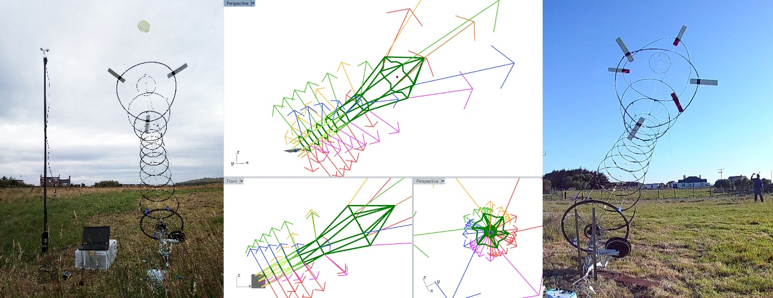fig.1 testing a single ring kite turbine, soft system modelling for scalability and a dual ring turbine test.
- Objectives
To assess safety aspects of network AWES. To assess the operating parameters of a mechanically autonomous kite-turbine which uses no active airborne control system. To compare the efficiency and scalability of rotary wing kite-turbine AWES with alternative AWES methods.
- Methodology
Initial investigation into the possible scope of viable AWES devices, [2] revealed a diverse set of potential designs. Observations of kite handling and performances, showed how widely anchored networks of small kites are more stable, safer and easily deployed at scale than large single kite systems. Testing also revealed autogyro stacking provides continuous power without control overheads. The hollow-axis kite turbine design, using sets of kite-blades on ring structures, was found by hybridising wide kite networks with a stacked autogyro.

The kite-turbine approximates the efficient wide path sweep of wind turbine blade tip sets but with the rotor top tilted to windward like an autogyro. The autogyro lift mitigates the need for a supporting tower architecture. This rotor type can also exploit the scaling benefits of tensile kite stacking.

Tensile Rotary Power Transmission (TRPT) has been investigated and described by Oliver Tulloch at University of Strathclyde [3]. TRPT is the transmission of torque to ground over tensile lines, which are held apart by rigid material. Models of kite turbine networks, capable of working without rigid ring material, have been developed. [4] The kite turbines tested use TRPT through the kite rings and a pure TRPT shaft section between the lower end of the kite-turbine and the ground station.

On small, simple-blade kite-turbines, a lift kite, (as commonly used for kite aerial photography) is first deployed and then used to improve the lift, turbine deployment and line tension (and thus transmission efficiency.) A back-line is also connected to the lifting kite line, above the turbine. The backline helps deployment, turbine positioning, recovery and safety. Network forms, which exploit multiple lift kites, for stability and deployment density have been modelled and tested.[4]

Various ground-stations have been successfully tested. The ground station can be as simple as an electric bike wheel attached to a tilted post, with tethers radially attached on the rim. Control of the torque on the Power-Take-Off wheel can be safely regulated according to overall line tension. This avoids the possibility of crushing the TRPT with torsion.

Concept designs and test results of systems <1kW have been openly published.[2]

- Results
Autogyro kite-turbines can be flown to generate power at a ground station without using any flight control system. A single ring kite-turbine, using 3x NACA4412 20cm chord 1m span foam blades, a lifter kite & TRPT sections, with total airborne mass <2kg, can output 1.5kW in 10m/s wind.
Kite-turbine efficiency can improve with stacking. Each additional stacked ring of kites, contributes only a short set of additional lines, hence, less total line drag per blade swept area in the turbine.
The continuous annular blade sweep can be positioned, using the backline to maintain optimal altitude for AWES dynamics in the kite wind window. Pulling the back-line around will yaw the turbine array so that it can be stalled and landed safely.
Arrays of small wings in multi-layer, mulit-kite topologies, reduce the mass & performance scaling penalties associated with single wing AWES scaling.[5]
Flying multiple kite blades, connected radially, around a physical flight track gives a much smoother AWES power output than single-wing airborne wind energy configurations. Stacking turbine rings also appears to smooth lateral vibration down the stack.

A component break, on networked AWES, has less severe consequences, than comparable component breakage on single-line AWES. (Usually resulting in only deteriorated performance as compared to catastrophic failure.) A simultaneous break of all 6 TRPT and 1 main lift lines resulted in the turbine remaining airborne, almost intact and recoverable, held by the backline and back anchor. The short lines between sections of networked AWES reduce lash-back risk. Short line sections also provide a platform to test the benefits of faired lines in AWES.
Turbines using foam blades Cp = 0.1 produce twice as much power as ram-air blades Cp = 0.05. [8]

The pure TRPT section on the lower part of the turbine will not have to scale in length as the turbine scales. The TRPT only has to transmit downward from the height of the first kite ring. The mass scaling of the pure TRPT compressive components is also mitigated by less need for rigidity while using multi line architectures, high lift kite blades and better beam construction. [6]
Multi-line multi-kite rotary power extraction mitigates AWES line abrasion, kite control and single point failure problems common to single line AWES designs. [7]
The cost of testing a series of prototypes over seven years was within a househusband’s budget.
Modelling suggests that any number of kites can be added onto a given network profile as long as their flight dynamic keeps within the set which allows whole net inflation for the torque demanded.
- Conclusions
The potential scale of a rotary kite network AWES is still unknown, but seems very large.
Networked AWES forms provide scope for a large variety of further tests and design optimisations.
Safety, cost, performance and simplicity of AWES improved by using networked kite power systems.

- References
[1] Read, R.: Kite Networks for Harvesting Wind Energy. Airborne Wind Energy Advances in Technology Development and Research. Singapore: Springer, pp. 515-537 (2018). https://doi.org/10.1007/978-981-10-1947-0_21
[2] http://windswept-and-interesting.co.uk/designs/
[3] Oliver Tulloch: Modeling Studies on Tensile Rotary Power Transmission for Airborne Wind Energy Systems, AWEC2019, 15-16 October, Glasgow, United Kingdom
Book of Abstracts, Page 159, edited by Roland Schmehl, Oliver Tulloch.
ISBN 978-94-6366-213-0 doi:10.4233/uuid:57fd203c-e069-11e9-9fcb-441ea15f7c9c shortdoi:10/dcjm
[4] Roderick Read: Practical Experimentation on Rotary Network AWES , AWEC2019, 15-16 October, Glasgow, United Kingdom Book of Abstracts, Page 59, edited by Roland Schmehl, Oliver Tulloch. ISBN 978-94-6366-213-0 doi:10.4233/uuid:57fd203c-e069-11e9-9fcb-441ea15f7c9c shortdoi:10/dcjm
[5] Jochem De Schutter, Rachel Leuthold, Thilo Bronnenmeyer, Reinhart Paelinck, Moritz Diehl: Towards a Modular Upscaling Strategy for Utility-Scale Airborne Wind Energy, AWEC2019, 15-16 October, Glasgow, United Kingdom Book of Abstracts, Page 159, edited by Roland Schmehl, Oliver Tulloch. ISBN 978-94-6366-213-0 doi:10.4233/uuid:57fd203c-e069-11e9-9fcb-441ea15f7c9c shortdoi:10/dcjm
[6] https://forum.awesystems.info/t/medium-scales-for-torque-transfer-systems-onshore-and-offshore/
[7] https://kitepower.nl/wp-content/uploads/2019-05-30_tether_failure_information.pdf
[8] Oliver Tulloch: Development of Safe and Eﬃcient Operation for an Airborne Wind Energy (AWE) System - A Rotary Design, Second Year Review

