Alternating single blade. *01/2024 – pf-rev 1.0*

Prototype 1 videos:

<https://mv.omegawatt.fr/wind/monopale_regulier.mp4>

<https://mv.omegawatt.fr/wind/monopale_et_generateur.mp4>

Openmodelica simulation 3 winches.

<https://mv.omegawatt.fr/wind/winchturbine3.wmv>

Concept: An adjustable blade is fixed in the extension of a mast which oscillates in a plane perpendicular to the incident wind. The blade thus sweeps a large surface, delimited by the start and end angles of the movement of the mast, of the order of +/-50° relative to the vertical. The pitch angle of the blade is constantly adjusted to extract maximum energy from the wind. The reciprocating movement of the mast is braked then restarted at the end of the stroke by counterweights and/or springs, and the energy is extracted from the movement by means of electrical systems (winches) or possibly hydraulic systems.

The maximum blade speed is of the order of 3 to 4 times the incident wind speed, and the chord is approximately 10 times that of a conventional three-blade horizontal axis wind turbine.

The blade can be cut into independent sections, stacked, rotating around the mast, driven by direct drive

brushless crowns. This facilitates transport, optimizes the incidence per section, and provides redundancy for feathering during an emergency stop.

The mast is possibly guyed between the bottom of the blade and the axis of the pivot on the ground, in order to take up the force linked to the lift on the blade.

The concept is applicable to offshore turbines, with a pivot which can be a floating pipe.



Interests:

Being more bulky, and subject to lower forces, the single blade can include, at least in part, a flexible skin and has a mass/surface ratio much lower than conventional blades, with various manufacturing possibilities, which can be inspired by the design of small aircraft wings.

The thickness of the profile makes it possible to increase the distance between the spar caps ensuring its rigidity, and reduces the constraints faced with the lift generated by the incident wind. As the quantity of spar material is reduced, carbon fiber can be used economically, with a reduced mass.

The size of the blade increases the Reynolds number and decreases the importance of the surface finish.

For large horizontal axis wind turbines, the weight of the blades sees its direction change sign with each half rotation and becomes the sizing constraint. This effect is significantly reduced with the single blade due to a reduced blade mass and a mast movement of around +/-45°.

For a classic propeller, the incidence cannot be optimal from the root to the tip of the blade. With the single blade, if it is composed of independent sections or independent flaps, the incidence can be more precisely adjusted, which is relevant in terms of efficiency and noise.

Disadvantages:

Lift is linked to the speed of the blade, and decreases with each reversal. It is essential to ensure a rapid recovery to regain lift capable of generating energy. Springs or non linear counterweights seem essential.

The acoustic impact of rollovers must be assessed.

The movement of the mast has a low amplitude and speed, which is not ideal for generating electricity. A robust and inexpensive solution consists of using a double-acting hydraulic cylinder and valves to power a hydraulic motor, then an electric generator. But this results in an energy loss of around 20%. Another possibility is to use winches (which could also drive up counterweights) :

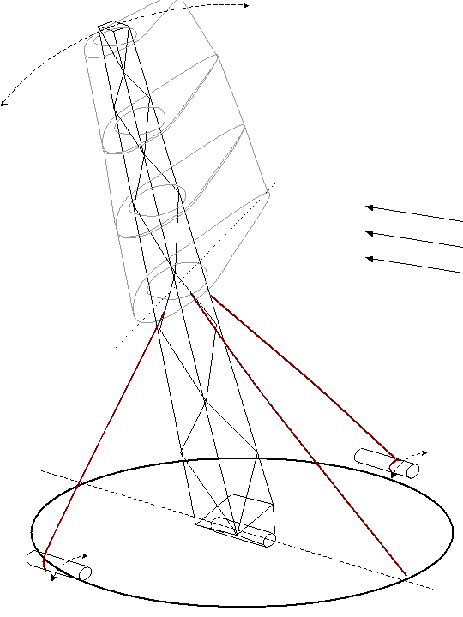

Except in special cases of very directive wind regimes, the assembly must be oriented facing the wind (a movement of 180° is however sufficient, because the blade has additional mobility).

It remains possible to use 3 winches at 120°, but this requires significant torque/power.

Lift causes a significant moment at the mast pivot, which tends to cause the pivot to change orientation when the blade is not vertical. For a guyed version (in the direction of the wind only), a circular rail centered around the pivot can be fixed to the ground, as a mobile point for attaching the guy lines.

In the floating version, the pivot could be a long tube with sufficient flotation to support the assembly, then capable of ensuring the oscillation and orientation movement.

Benefits:

The single blade does not have a nacelle, and the weight is reduced, so transport and installation are simplified.

The speed at the tip of the blade being much lower than that of conventional wind turbines (30m/s instead of 70), noise is reduced. Maintaining the blade surface is much easier since the single blade can be brought to the ground, reducing noise related to imperfections/dirt. A relatively fragile flexible surface (plastic film) is possible for the low pressure zones of the blade surface.

There is no risk of runaway, because maintaining the movement absolutely requires that the blade orientation system works correctly. Stopping it quickly interrupts energy capture.

Given its low weight above the anchors, the single blade has advantages for floating use.

The wake of a single blade is less disturbed than that of a conventional wind turbine, which induces a rotational movement in the fluid and more energy losses for larger wind farms.

Similar machines:

1. Econologica.org uniblade Wing [1].

Very similar principle, however with a mechanical blade orientation system which is achieved by a mechanical tilting between two positions, with a fixed setting after each reversal. The author mentions a "phase advance of 65°" and a video [2] shows a leading edge vortex which detaches at the end of the cycle (due to the aerodynamic stall linked to the slowing down of the blade) and seems to help change the orientation of the blade. Dimensions of around 5 meters at the end of the blade and 50cm chord. Amplitude of movement at +/-90°. Raised pivot approximately 1.5m from the ground.

Seems capable of delivering around 250W at low wind speed.

2. Stingray [3], Pulse Tidal:

Horizontal blade and pivot pin. The blade naturally orients itself in the current bed. Low blade elongation, but presence of simple winglets. H0/c of around 5. Rated power of around 100kW for StingRay.

The movement of the blade is not in a plane normal to the flow, but the blade "advances" at the end of the cycle, so its speed relative to the fluid is modified in a penalizing manner.

Both projects failed economically. A recent interview with Pulse Tidal's technical lead discusses "harsh laws of economics and physics." StingRay mechanical design limitted blade pitch angle, strongly impacting efficiency.

2. Biostream [4]

Vertical blade and rotation axis. “Shark wing” or delta wing surface. As in the previous case, the movement is not in a plane normal to the flow.

Single-blade wind turbine prototype produced:

Rope: 450mm, NACA0020, Rotation axis: 27.5% rope, Blade length: 2.5m + mast 3m

|  |  |
| --- | --- |
|  | ressorts |
| *Overall view.*  *Dyneema shrouds diameter 2mm.* | *View counterweight and springs,*  *circular arc rack (black PVC)* |

|  |  |  |
| --- | --- | --- |
|  |  |  |
| *Blade spar: pultruded carbon rods in the corners, Airex PVC foam, 1.2mm plywood then 0.2mm carbon sock* | *Gluing the elements with epoxy.*  *The carbon tube of the mast fits into the lower part of the spar over 0.75m* | *Brushless generator and vector control card*  *(card since replaced)* |

|  |  |
| --- | --- |
|  | Ribs: Airex thickness 10mm + okoume plywood 1.2mm.  Leading and trailing edges: Balsa + carbon rods  Front skin: 1.2mm okoume plywood  4 toothed rings are attached to the spar.  The motor is mobile (fixed on a rib)  The motor shaft is extended over the entire length of the blade and drives the ribs by toothed belts. |
| moteur |  |
|  |  |
| couronne solidaire du longeron  axe moteur  roulement à aiguilles |  |

Onboard sensors:

-Foot and tip of blade: IMU 9dof: 3 accelerations, 3 gyros and 3 compasses

-Pounding motor: optical encoder – current, voltage – position reference

-2 pitot tubes + 2 angle of attack sensors (differential pressure at +/-95% of chord)

On the chassis:

-Generator: mast position encoder, current, voltage, power, speed.

CAN bus communication to a PC. Acquisition possible at 100Hz for fast sensors.

The heave motor position and generator braking current instructions are calculated on the generator control card and transmitted by CAN bus. The algorithm parameters can be modified via the CAN bus with the PC software.



*Example of measurement record (time axis in hundredths of seconds)*

*For example, we notice oscillations (gyro gz),*

*more accentuated at the top than at the base of the blade.*

Theoretical study:

Taking into account the oscillating movement, a symmetrical profile is imperative for the blade (except for a larger dimension, where it is possible for the trailing edge to be a movable profile relative to the main body of the blade, as for rigid wing catamarans ). The studies carried out seem to indicate that the thickness of the profile has little impact on efficiency up to values of around 20%, but the data on thicker profiles is scarce. Resistance to mechanical stress with a minimum of mass favors a thick profile, and NACA0020 was retained for the calculations.

The position of the axis of rotation of the profile relative to the chord has relatively little impact on the flows for large amplitude movements. However, it is decisive for the engine torque to be ensured to control a precise angle of incidence. A compromise must be chosen to limit this torque, while allowing natural feathering by weathervane effect in the event of engine failure. A choice of 27.5% of the rope was retained. It should be noted that for long one-piece blades, the deformation of the spar under lift leads to a more complex movement during changes of incidence. On the other hand, with a blade made in several movable sections around a mast, it is possible to guarantee the position of the axis of rotation, and even to compensate for the torsional deformation of the mast (with an absolute orientation sensor, by 3D magnetic compass, or even according to the resistant torque measured at the orientation motor). The ideal is to develop real angle of attack sensors, for example based on pressure measurements on either side of the leading edge.

In the study, the blade is considered rigid and in pure rotation around an axis.

The effectiveness of oscillating blades has been studied for cases of moderate amplitude (H0/c <3) and with sinusoidal movements [5]. These studies highlight an optimal peak incidence of 33° and a maximum efficiency which decreases when H0/c increases, sinusoidal control being less and less suitable.

Law of movement:

For higher amplitudes, which interest us here, sinusoidal movements with a phase shift of 90° lead to real counterproductive incidences as soon as H0/c exceeds 2.

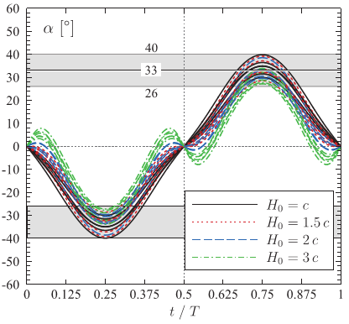

A simple choice of movement consists of maintaining a sinusoidal pitch, and calculating the heave so as to obtain a sinusoidal incidence [7]:

|  |  |
| --- | --- |
|  |  |
| H0/c = 5 | H0/c = 10 |

With a sinusoidal heave out of phase by 90° (pink curve), the angle of attack (light blue AoA) is unfavorable near the reversals. With heave corrected (blue), the angle of attack is sinusoidal with a peak at 33°.

2D and 3D simulation:

Produced by the LMFN (Quebec).

“Oscillating-Foil Turbine Operating at Large Heaving Amplitudes” (https://doi.org/10.2514/1.J058505)

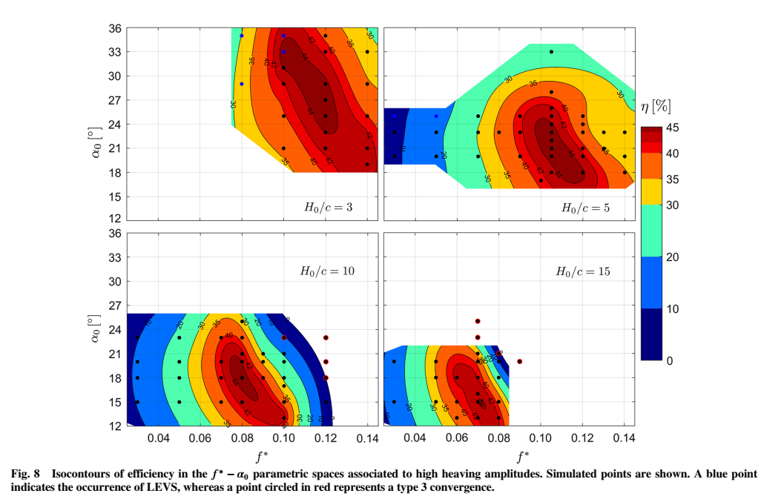

Efficiencies of around 75% of the Betz limit can be maintained for large amplitude sweeps provided a sufficient oscillation frequency:

For Ho/c = 10, the reduced frequency is approximately 0.08. For example, for a blade 100m long, performing a sweep of +/-60° (so Ho=100m), with a blade of 10m chord, the sweeping frequency for a wind of 5m/s would be 0.04Hz ( 25 seconds per round trip) and double that for 10m/s.

References:

[1] Econologica.org uniblade Wing for pumping

<https://www.youtube.com/watch?v=hEeAiuIL8Ew>

[2] Leading edge vortex shedding at the end of the swing of the flutter engine windpump

<https://www.youtube.com/watch?v=16kB6p-kcC0>

[3] StingRay phase 3 report:

<https://tethys.pnnl.gov/sites/default/files/publications/Stingray_Tidal_Stream_Energy_Device.pdf>

[4] Biostream website: <http://bps.energy/biostream>

[5] AIAA Kinsey, Dumas, 2014:

<https://www.researchgate.net/publication/275334785_Optimal_Operating_Parameters_for_an_Oscillating_Foil_Turbine_at_Reynolds_Number_500000>

[6] Unsteady Aerodynamic Forces at Low Airfoil Pitching Rates

<http://www.dtic.mil/cgi-bin/GetTRDoc?Location=U2&doc=GetTRDoc.pdf&AD=ADA228102>

[7] see: aoa_selon_mouvement.xls

[8]

<https://www.researchgate.net/publication/260519789_A_review_on_flow_energy_harvesters_based_on_flapping_foils>

[9] Simulations in a simple BEM model for the single blade. Calculation model in 4 blade sections, of the evolution of all parameters every 10ms for a few movement cycles. In Excel.

<http://www.omegawatt.fr/wind/simu_v7.zip>

[10] “Oscillating-Foil Turbine Operating at Large Heaving Amplitudes” LMFN / Dumas https://doi.org/10.2514/1.J058505